Walter Hernandez

DAD-220-R2169

November 8th, 2023

Module Two Assignment

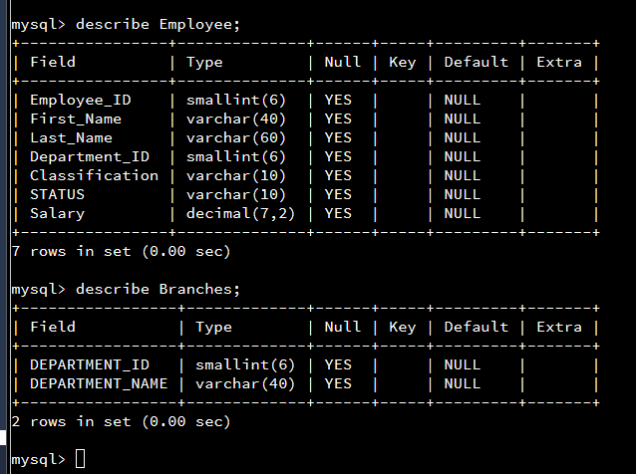 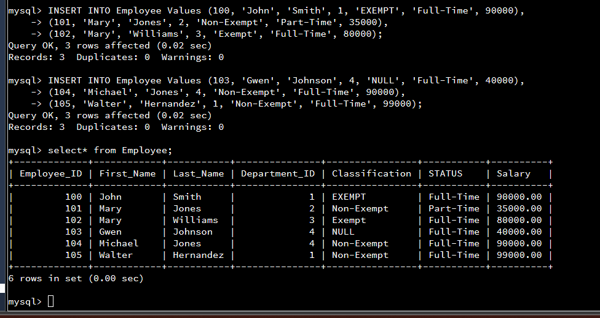

We then use then begin to input the values using the INSERT command. We insert several employee values. I also inserted my own name as an employee.

We begin the project by creating the two tables with the fields and parameters. We then use the describe command to initiate the tables that we created.

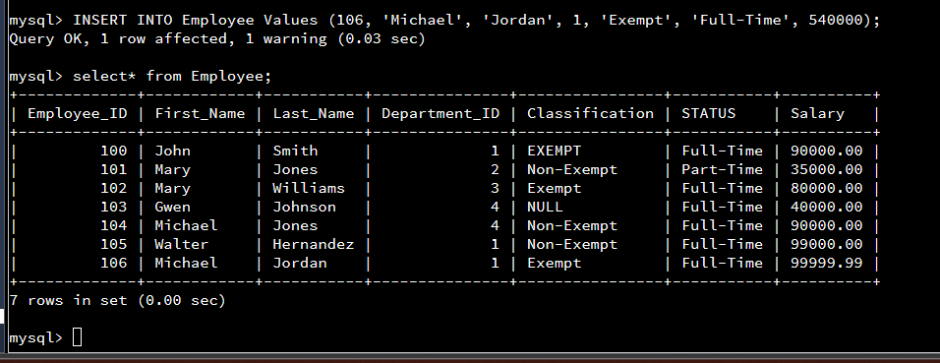

Finally, we use a command to select specific columns from our table. In this example we selected first name, last name, employee ID, and Department ID.

In the third part, we enter values for an athlete. In this case I used Michael Jordan as an example.